Key points for students
Using Audacity
To import an audio file in Audacity click on File – Import – Audio:
Selection Tool
Envelope Tool
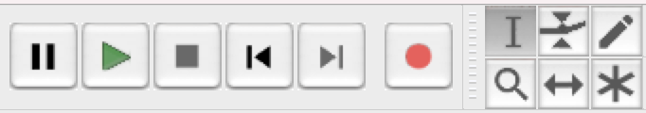
Time Shift Tool

Time Shift Tool – Use this to move audio files around.
Selection Tool – Use this to select audio that you wish to trim from the track and then press delete.
Recording
To record a voiceover click on Tracks – Add New – Stereo Track. Make sure that your microphone is positioned properly and press the red ‘Record’ button. When you have finished press the ‘Stop’ button.
Playback
Click on the green ‘Play’ button to listen to the audio and the ‘Stop’ button to stop playback.
To mute one or more tracks during playback, click on the ‘Mute’ Tab at the start of the track.

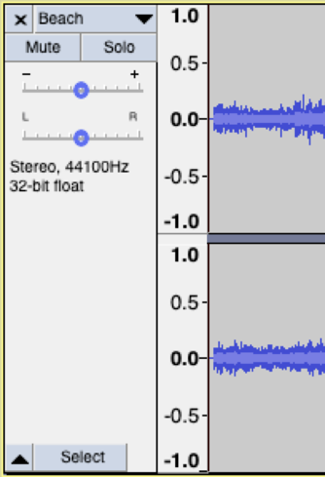
Audio effects
To add audio effects, select the audio track, or portion of track, required then select the desired effect from the drop-down list under the ‘Effects’ tab. Some effects can be previewed before the effect is applied to make sure that settings are appropriate.
Envelope Tool
The envelope tool can be used to adjust the volume of a track at different points. Click on the envelope tool and then use your cursor to adjust the volume of different parts of the track.
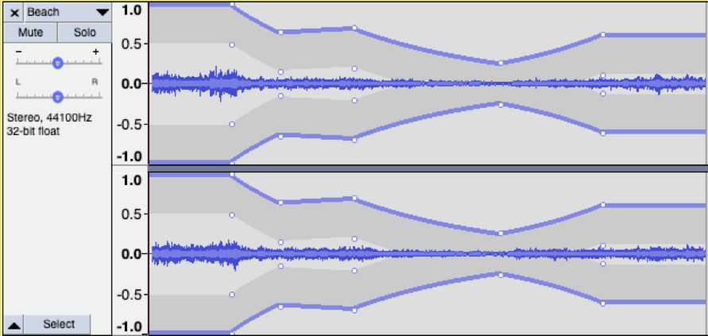
Using OpenShot
To import assets into OpenShot, open the folder containing the assets, select the files and drag them into the ‘Project Files’ window.
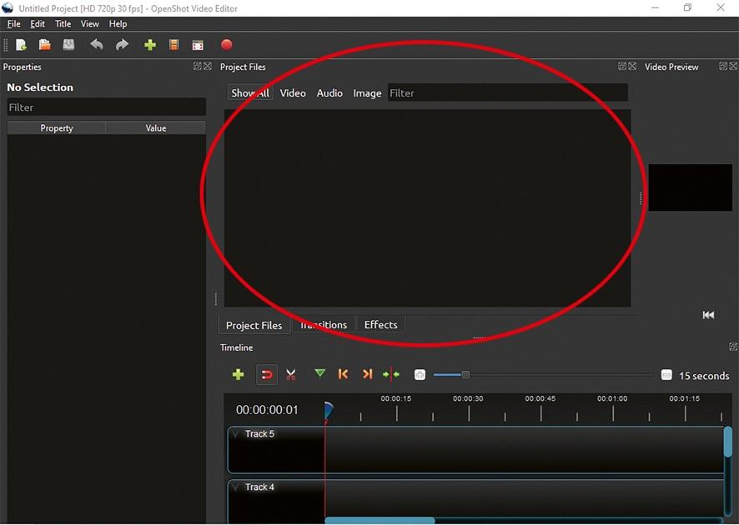
Arranging assets
To arrange the assets, drag them to the stage. The stage is layered, with a higher track playing over the tracks below it, so if the logo is placed above a video clip, it plays over the top of the video clip, but, if the logo is placed below a video clip, you can’t see it because the video is layered over the top of it.
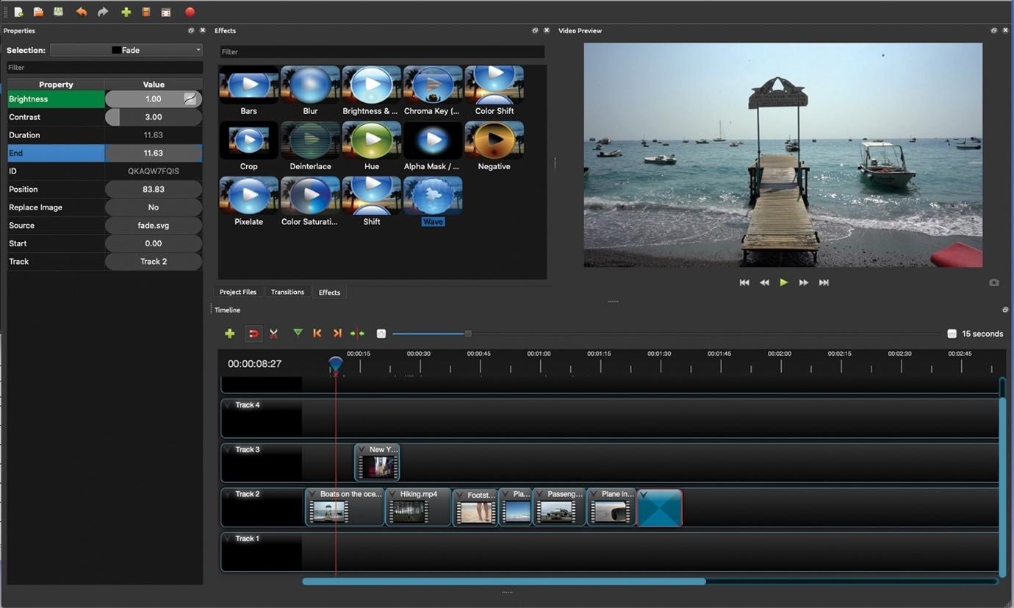
Editing assets
Click on the right-hand side or the left-hand side of an asset and drag to adjust how long it plays for.
To cut a video clip, position the playhead in the place you want to cut the clip, right-click on the clip and select ‘Slice’ and choose between ‘Keep Both Sides, ‘Keep Left Side’ or ‘Keep Right Side’.
Positioning a logo
Position the logo where you want it on screen by right-clicking on the logo, selecting ‘Layout’ and choosing one of the options available.
Playback
Press the spacebar to play the video. It will play from wherever the playhead is positioned. You can move the playhead by clicking and dragging it or by clicking in the timeline.

Transitions
To add a transition between video clips, click on the ‘transitions’ tab, choose a transition, drag it to the appropriate track and trim it.
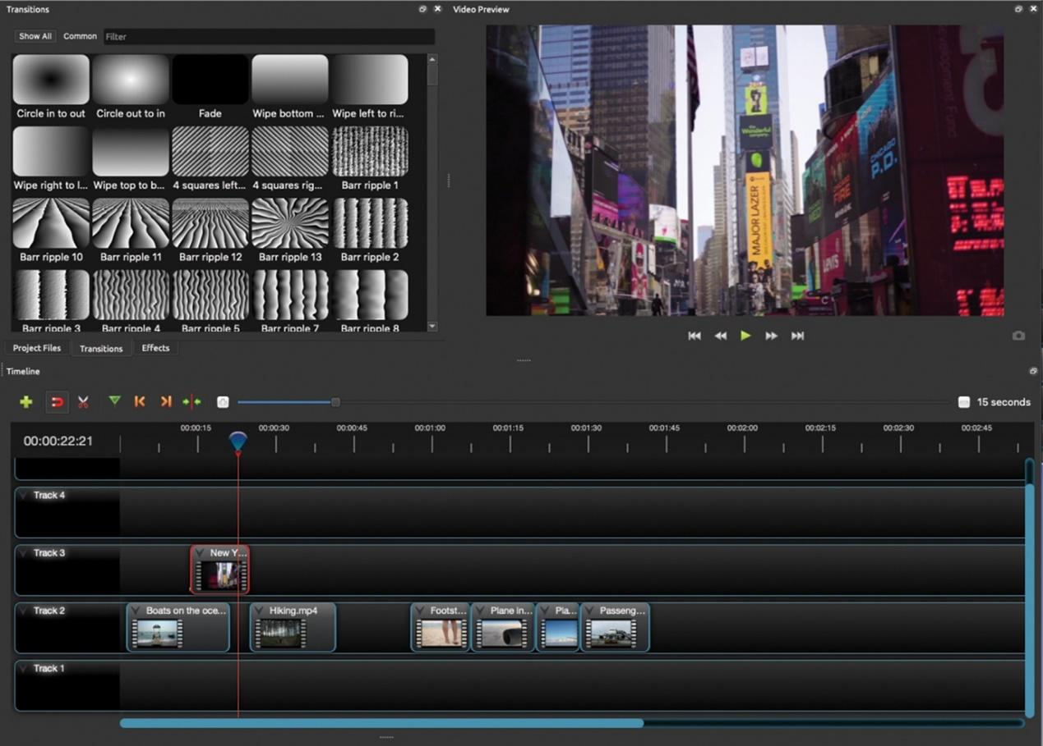
Other visual effects
To apply other visual effects, click on the ‘Effects’ tab, choose an effect and drag it to the appropriate track. Then click on it and adjust the values of each property of the effect.
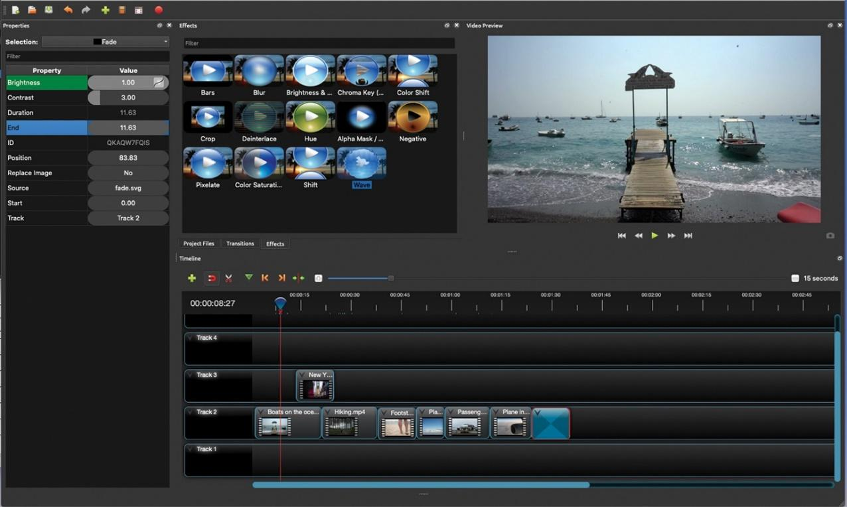
Titles
To add extra text to your video, click on ‘Title’ in the menu bar, then ‘Title’ and choose a template. Type in the text and adjust the font, text colour and background colour and click ‘Save’. Finally, drag the title to a new track and trim it as required.
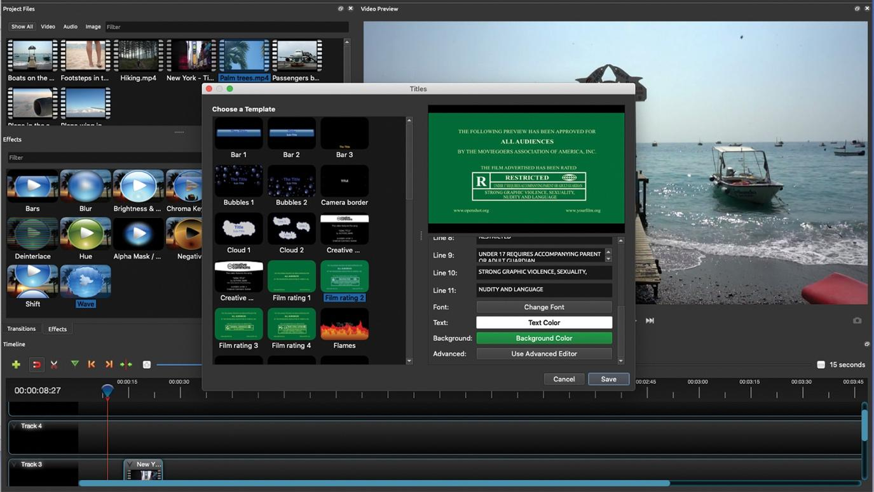
Exporting your video
Click on ‘File’ in the menu bar, ‘Export Project’ and ‘Export Video’.
Type in the file name and choose where you want the exported video to save to in the ‘Folder Path:’ box. Then make sure the following options are selected and click ‘Export Video’.
